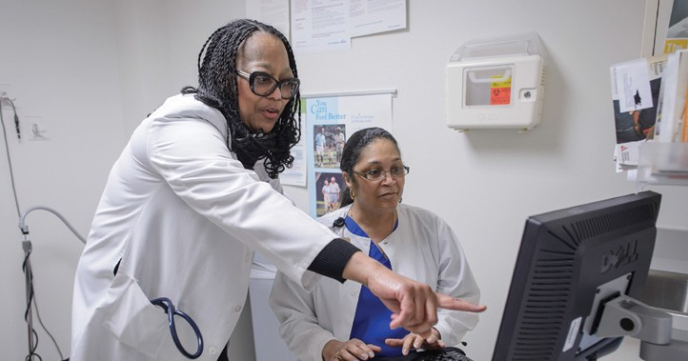
MAKE THE WORKPLACE SAFER
FOLLOW-UP & TRACKING CHART

Propose Solutions

For any “no” answers, think about solutions or ways to address the problem.
- First, think about ways to remove the hazard. This makes your workplace safer and ensures all workers are protected.
- If that’s not possible, think about any policies, procedures or personal protective equipment that is necessary.
- Think about what changes you can make on your own and what changes you need to partner with others (such as other workers, supervisors, facility management) to do.
Write your suggestions for solutions on the “Step 1: Identify Hazards” checklist and on the tracking chart on the next page.

Take Action

Report any safety hazards you identify. Use the following chart to track and make sure the problems are resolved.
- Give a copy of your hazard checklist findings to your supervisor or department manager, your UBT labor co-lead, and your Safety Team representative.
- Decide who else should receive a copy of your findings, such as members of the UBT or Safety Committee or your shop steward. Make a note of who you gave it to and the date.
- Follow up after a few weeks. If the problem was not addressed or resolved, think about your next steps.
+ Who should be informed?
+ Who can help you advocate for the needed solution?

