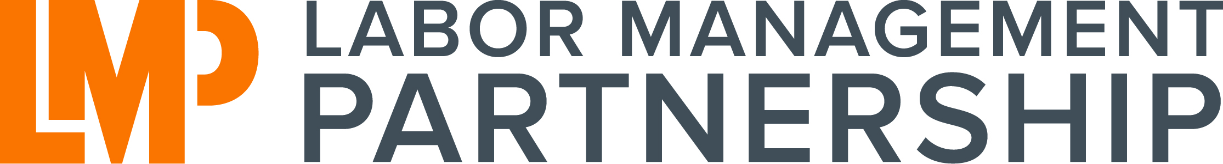 | UBT Support Evaluation

LMP Team Name: ________________________________________

Primary Support Person: ____________________________________

Support Period: ________________________________________

For each key element of team support below, please indicate the level of effectiveness that your support person(s) provided for your group.

PROCESS  How a team conducts its work in a partnership environment is as important as the issues it is working on. Focus on collaborative processes ensures that group work is effective, results oriented, and dedicated to the principles and guidelines of our Labor Management Partnership. |  | Did not effectively provide |  | Somewhat Effective |  | Very Effective
1. | Model facilitation skills and/or meeting management skills as needed by the team
2. | Explain and guide the group in Consensus Decision Making and Rapid Improvement Method while working on issues
3. | Lead group in clarifying information and building agreements
4. | Provide opportunity for team self-analysis by use of plus/delta or other form of group evaluation
5. | Provide observation and specific feedback to the team and/or the Co-Leads to further effectiveness of the team’s work
RESULTS
Results orientation is a consistent demonstration of concern for producing high quality results related to the purpose of the group and their jointly identified desired outcomes. The role of the facilitator is to help the group remain focused on their goals and attainment of results.

1. | Redirect or refocus group to desired outcomes when discussion goes off-track (or coach Co-Leads in doing this)
2. | Remain neutral regarding content; not influencing outcomes in favor of either labor or management
3. | Provide suggestions for processes and follow-through activities to help team to accomplish as much as possible toward desired outcomes in and between meetings
Supporting Comments:

PEOPLE  How people feel about the work they do together is another important aspect of team success. A facilitator should guide the group in developing agreements and practices that will support positive experiences, healthy relationships, and a collaborative environment. |  | Did not demonstrate |  | Somewhat Effective |  | Very Effective
1. | Ensure, through process, that all team members are provided with an opportunity to share their thoughts, ideas and perspectives
2. | Encourage participation by inviting input, active listening and encouragement of balanced conversation in discussions
3. | Focus on positive outcomes by acknowledgement of agreements, action items, important milestones, and accomplishment of results
4. | Provide feedback, when necessary, in a direct, honest and respectful manner
5. | Identify and arrange for “just-in-time” training needed by team members

Additional Team Comments:

Prepared By:

__________________________________________ | __________________________________________
Management Co-lead Date | Labor Co-lead Date

Please return completed form directly to Kim Labiaga, HR Director
via e-mail at Kim.M.Labiaga@kp.org
or interoffice to Fontana Medical Center, HR Office

