Introduction

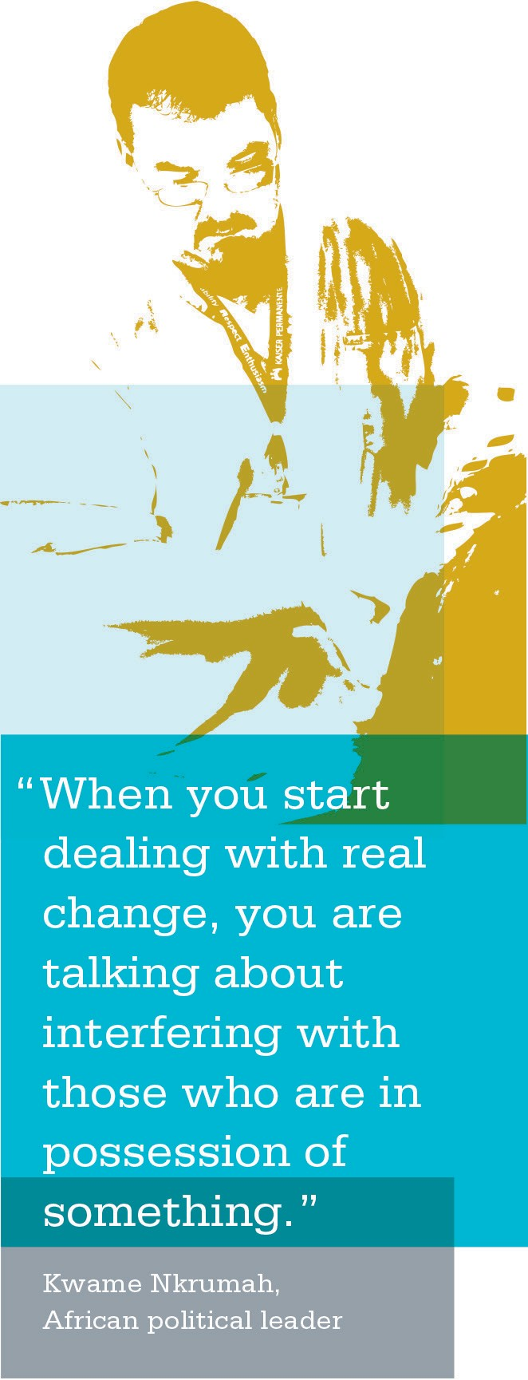
As a co-lead, you’ve been given the role of leading the unit- based team to achieve important goals. This is an exciting opportunity—individuals with different backgrounds and ideas are forming a team to improve performance and patient satisfaction—and your role is to facilitate the process.
As you begin your initial meetings, team members learn about each other and begin to get comfortable with the group. During this stage, members will naturally try to understand their own roles, the roles of the other team members and their purpose within the group. Team members may be unsure, nervous and even skeptical.
This is entirely natural and expected in the beginning stage of team development.

Steps to Complete
To ease their minds and set a strong foundation for unit-based team members to begin working together, it’s important to begin with an organized approach. At this stage in the process, completing the following steps will help your team begin with a strong start:
- Hold a Successful Kick-off Meeting
- Create the Team Vision, Working Agreements and Charter
- Complete a Training Assessment
- Hold a Successful Kick-off Meeting

Early in the formation of a UBT, the sponsors will identify the area(s) of focus for the team. This information should be translated to the team during your initial kick-off meeting. A kick-off meeting should be held to define the team’s purpose and two or three meetings thereafter should be held to determine how the team will work together and improve its skills to become a high-performing team.

First impressions are lasting impressions—a kick-off meeting that is structured and well organized will help your team trust that future work will be successful.
Holding a Successful Kick-off Meeting
- UBT Roles Chart
- Checklist for Starting a UBT
- Co-Lead Action Planning Worksheet
- Agenda for UBT Kick-off Meeting
Creating the Team Vision, Working
Agreements and Charter
- Value Compass Activity
- Team Vision Worksheet Activity
- UBT Team Charter Activity
Completing a
Training Assessment
- Training Assessment Tool Checklist
- UBT Training Courses

- Create the Team Vision, Working Agreements and Charter

To ensure all members are on the same path as you move forward, a team vision should be created to identify the team’s key values, goals and guiding beliefs. Through this process, the team as a whole commits itself to one or more initiatives and the team’s purpose is defined.
Defining the team’s purpose provides an opportunity for UBT members to understand why their work is important and helps create buy-in by answering the “why am I here?” and “what’s in it for me?” questions UBT members may be asking themselves during this stage.
Working agreements (ground rules, norms, expectations, etc.) are to be established to guide how the team will work together to achieve results; then, a team charter is created. A charter is simply a written outline of the team’s working agreements.
- Complete a Training Assessment

Each team member offers his or her unique experience from different levels within the work unit. In some cases, training may need to be completed to build skills or competencies to help the team complete a particular task or project. Completing a training assessment at this stage will ensure your team members are well prepared to effectively manage the tasks and goals that lie ahead.

Job Aids, Tools and Templates
The job aids, tools and templates listed in the box at left are included in this section of the toolkit to help you.

Using the UBT Roles Document
Purpose
This chart provides information regarding the different UBT roles and their responsibilities.

How to Use
Use this chart with your co-lead to help you understand your roles and to communicate and give clarity to other team members regarding what their roles and responsibilities are.

When to Use
When preparing for your first UBT co-lead meeting and your first UBT meeting.

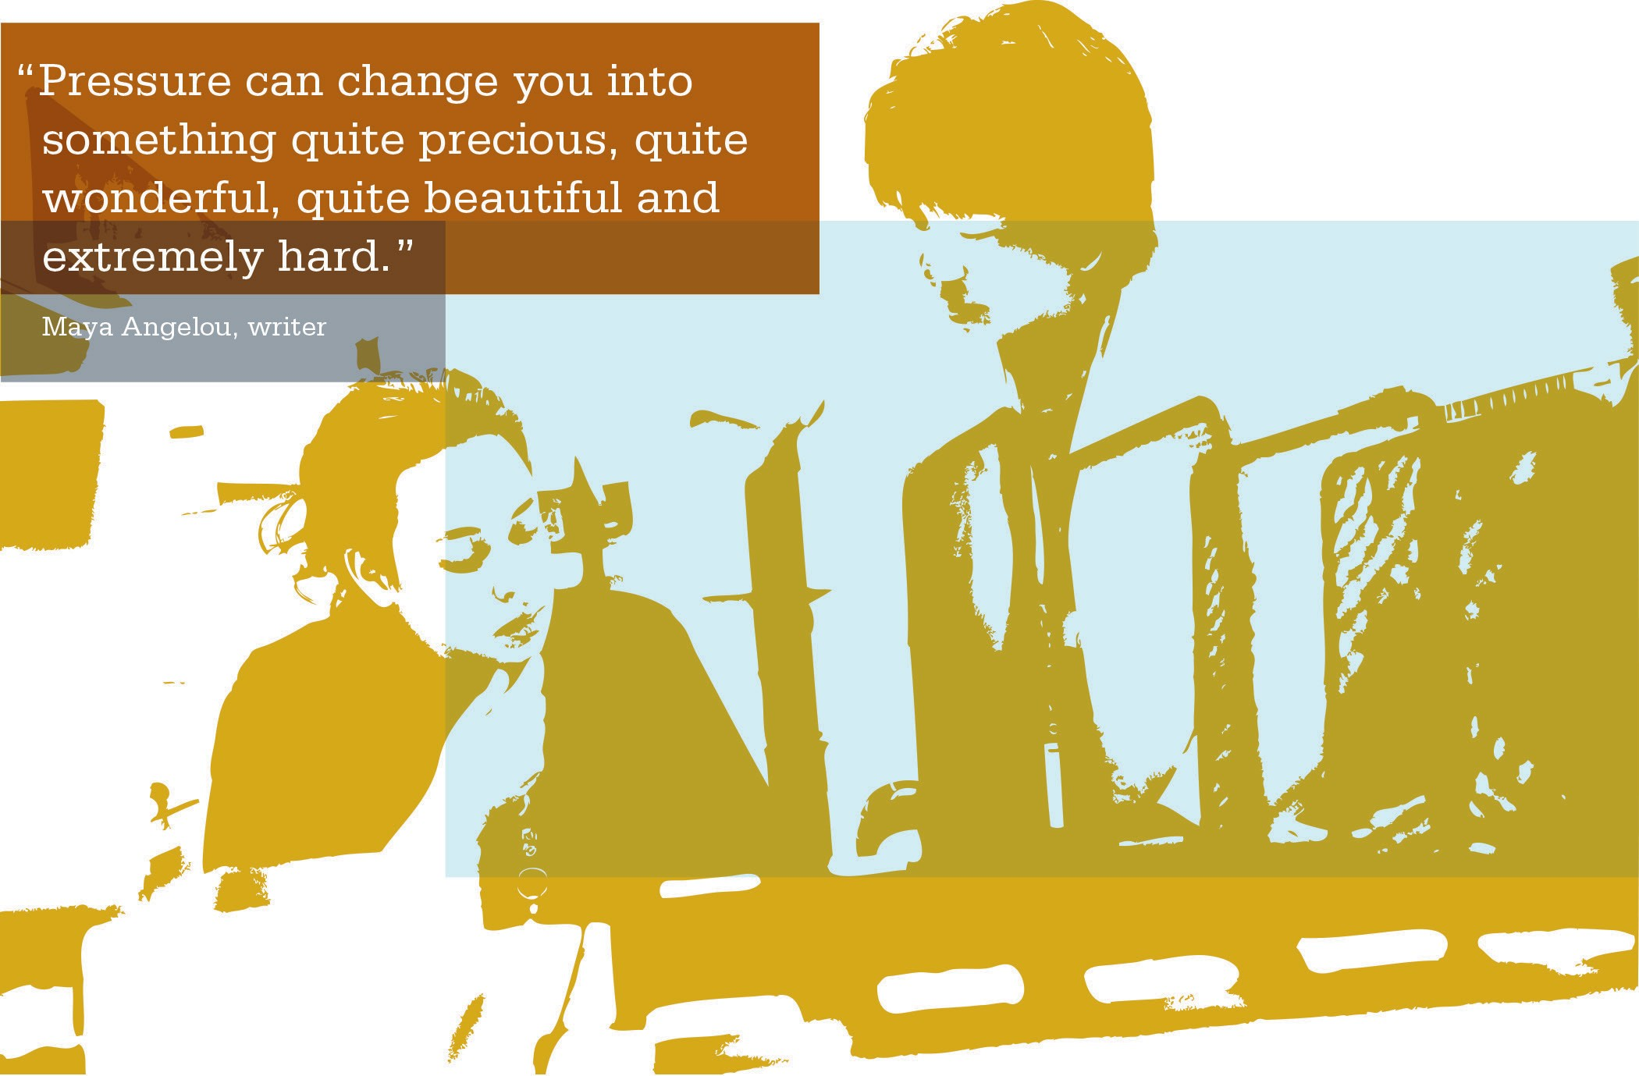

UBT ROLES
Team Members: | - Attend and participate in meetings  - Complete UBT training  - Represent interests and perspectives of others—not just your own  - Use UBT processes collaboratively and with an open mind toward mutually acceptable results  - Maintain open, direct and respectful communication  - Support partnership principles  - Communicate regularly with staff  - Honor confidentiality agreements  - Actively support all team decisions
Co-Leads: | - Advocate for partnership success  - Communicate early and often  - Prepare for meetings and huddles  - Use appropriate meeting management tools  - Troubleshoot where appropriate  - Act as point person for information  - Keep team records  - Ensure team is following charter and charter is relevant  - Communicate with others (including sponsors and stakeholders)  - Make off-line decisions when needed  - Build relationships and share expectations with co-lead partner(s)
Sponsors: | - Support the Partnership  - Keep UBT visible and aim for success  - Authorize, legitimize and demonstrate ownership for change  - Allocate resources for success  - Know who is doing what  - Walk the talk
All UBT Staff: | - DO select/elect team members you know will be willing and able to represent the various interests of you and your co-workers  - DO share ideas, suggestions and opinions related to issues being addressed by the team  - DON’T expect the team to work on issues inappropriate to UBT work  - DO ask what the team is working on and stay involved with its progress  - DON’T ask the team to share confidential info or “who said what”

ACTIVITY: Checklist for Starting a UBT
Purpose
This checklist is a guide for you to chart your UBT startup progress. It highlights the important components that must be identified and in place for a UBT to be successful.
After completion of all items on the checklist, the UBT will be ready to work as a team to improve performance. Review this checklist before you begin working with your team. Check off items as you begin working together to ensure the team is ready to begin.

Team Type: (select the applicable choice)

Project Team (select one below) [ ] Scope of work
[ ] work unit [ ] department [ ] Decision-making process(s) agreed to
[ ] facility [ ] medical center [ ] Goals, targets, metrics
Governance Team (select one below) [ ] Quorum established for:
[ ] work unit [ ] department [ ] Working agreements—holding a
[ ] facility [ ] medical center meeting—decision making
Team Sponsorship: [ ] Communication plan established to: all staff—stakeholders—sponsors
[ ] Sponsorship obtained from
management and labor at appropriate Team Member UBT Training:
levels [ ] Training needs assessed
[ ] Team readiness assessed, including [ ] Appropriate training completed adequate functional relationships
Facilitation: (select one below)
[ ] Goals and scope of work clarified
[ ] Internal—by team members, for
[ ] Adequate resources available meeting management in regular
Team Membership: situations
[ ] Size of team determined [ ] External—neutral facilitator, for
[ ] Co-leads selected difficult issues (e.g., formal issue resolution) and/or when relationships
[ ] Composition of team determined are strained
Team Charter:
[ ] Team purpose
[ ] Roles: recorder, timekeeper, facilitator

Using the Co-Lead Action Planning Worksheet for Creating Working Agreements
Purpose
Co-leads use this action planning worksheet to get agreements on how they will work together.

How to Use
Use the template to discuss working styles, communication styles and to plan how to effectively facilitate meetings together. For more information, go to Section 9: Appendix/Additional Resources.

When to Use
Co-leads can use this template when they first begin to work together and to plan UBT meetings.
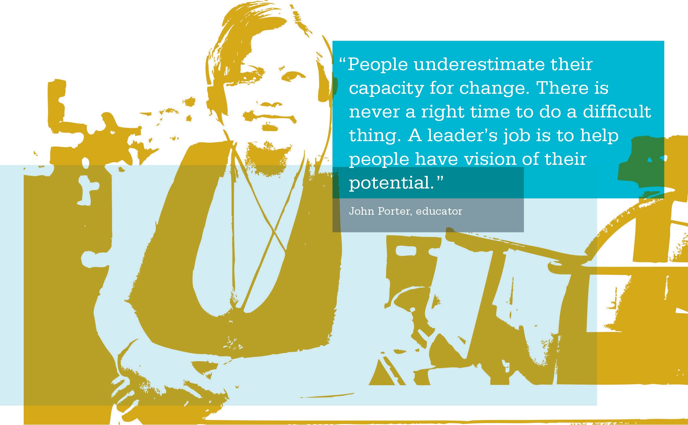

ACTIVITY: Co-Lead Action Planning Worksheet
UBT Name:

Management Co-Lead:

Labor Co-Lead:

Use this worksheet to capture working agreements between co-leads in the following areas:

Co-Lead Working Styles:

- Communication preferences (in person, email, phone, etc.)

- What agreements do we have about handling conflict?

ACTIVITY: Co-Lead Action Planning Worksheet (continued)
3. Where would you appreciate support?

Team Charter and Other Working Agreements:

- Do we want to use a charter?

- What might be in the charter? Do we want to use the standard charter template tool for our charter?

- If we have a charter, are there gaps in it?

ACTIVITY: Co-Lead Action Planning Worksheet (continued)
Planning for Meetings:

When do we need to meet to plan, who is creating the agenda, etc.?

Opening Meetings:

Who will facilitate the opening, what will we need to say?

Running Meetings:

Who facilitates which topics, what do we want?

ACTIVITY: Co-Lead Action Planning Worksheet (continued)

Closing Meetings:

What actions do we take to close our meetings?

Other Issues or Concerns for Sponsors to Address:

Agenda for UBT Kick-off Meeting
Purpose
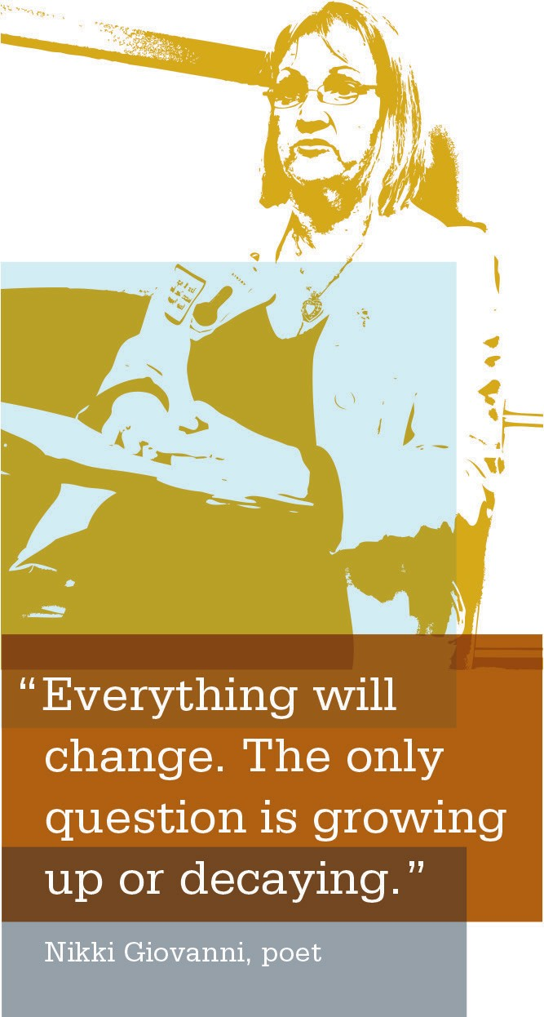
The UBT kick-off meeting sets the stage for future out- comes and working agreements for the UBT. A kick-off meeting that is well organized, with a clearly defined agenda and outcomes, will help your team members feel confident that future meetings will be efficient. The sample agenda provides you with an idea of what might be covered for the best outcomes.

How to Use
Use the sample agenda on the following page as a tool to ensure you are covering the necessary steps for a successful kick-off meeting.

Checklist for a Successful Kick-off Meeting
[ | ] | Review the sample agenda. Create your own version making any necessary modifications.
[ | ] | Distribute a copy of the agenda to your team prior to your meeting.
[ | ] | Meet with your co-lead to get clarity on who has what role during the kick-off.
[ | ] | Prepare any materials that need to be presented to UBT members.
[ | ] | Determine whether the sponsor needs to be present at the kick-off meeting. If so, create space at the beginning of the agenda for the sponsor to set the context of the UBT work for the organization.

Sample Agenda 1
Meeting Name: Cascade Park Family Practice UBT
Meeting Purpose: Kick Off the Family Practice UBT
Date: Jan. 7, 2009
Time: 1:30–3 p.m.
Location: Conference Room 2
Desired Outcomes:
- Set the context of UBT work
- Understanding of UBT roles and initial business objectives of this unit-based team: Increasing service scores
- Create UBT meeting ground rules and review agenda
- Understanding of service scores (team members see the correlation between service delivery and patient satisfaction)
- A list of issues related to service in our unit
- Agreement on solutions that can be implemented immediately
- A list of action items and communication needs

Topic (What) | Process (How) | Who | Time
Opening:  - Context  - Desired Outcome  - Agenda  - Roles  - Safety Tip | - Present  - Check for understanding  - Check for agreement | David—Labor co-lead/Rose—  management co-lead | 30 minutes
Service Performance Update | - Review and explain the data  - Check for understanding or questions | Rose | 15 minutes
Identify Service Issues | - Brainstorm | David | 15 minutes
Possible Solutions | - Narrow the brainstorm list and agree on solutions that can be implemented immediately | All | 10 minutes
Next Steps  - Action Items  - Communication Needs | - Agree on action plan  - Agree on what needs to be communicated, to whom, by when and how | Rose | 10 minutes
Meeting Evaluation | - Conduct plus/delta | David | 5 minutes

Value Compass Activity Checklist
[ | ] | Review the Value Compass with your team and explain the key points on the compass and what they mean.
[ | ] | Have the team take a few minutes to review the scorecard indicators.
[ | ] | Ask team members to review the Value Compass and review the questions on the following page.
[ | ] | After team members have had an opportunity to review the scorecard indicators, Value Compass and questions, debrief by asking the team to share responses to the questions.
[ | ] | Flipchart or whiteboard their responses and ask for a scribe to take note of the information for future reference as your team creates its charter.

ACTIVITY: Value Compass
Purpose
The Value Compass sets the direction for improving organizational performance by focusing on the health plan member and patient. This activity provides an opportunity for the UBT to analyze the Value Compass to determine why its work is important and to identify where the unit stands regarding the points on the compass in comparison with where it needs to be. As a co-lead, your job with this activity is to facilitate an open dialogue with the UBT regarding how well the work unit is performing on each of the points on the compass. This activity helps the UBT define its purpose as team members will identify areas in their work unit that require improvement.

Outcomes
After successful completion of this activity, participants will define the purpose of their work, determine why their work is important and identify key areas that require improvement.

Instructions
Before you meet with the team, pull score card indicators for your work unit and prepare copies to distribute to your team. Hand out copies to your team members along with the Value Compass and the questions shown on the following page.

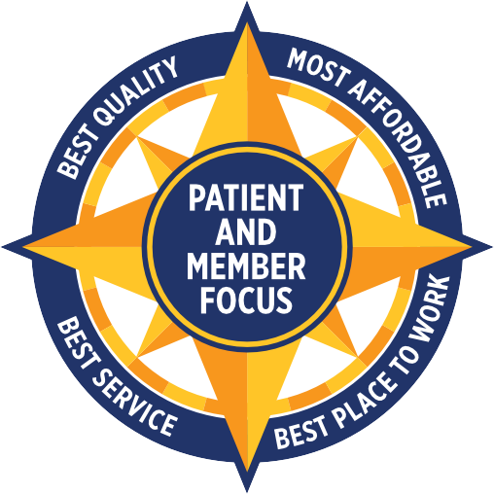

ACTIVITY: Value Compass (continued)
Review your scorecard
indicators. Compare your scores against each of the
points on the Value Compass.

- What does it mean to be patient- and member- focused?

- How is your work unit performing in each of the points on the compass?

ACTIVITY: Value Compass (continued)
- How can your work unit improve in these areas? Where do you need to be with your scores in each of these areas?

- What can your UBT do to improve your scores and be more patient- and member-focused?

- How will improvement in these areas make work life better for you?

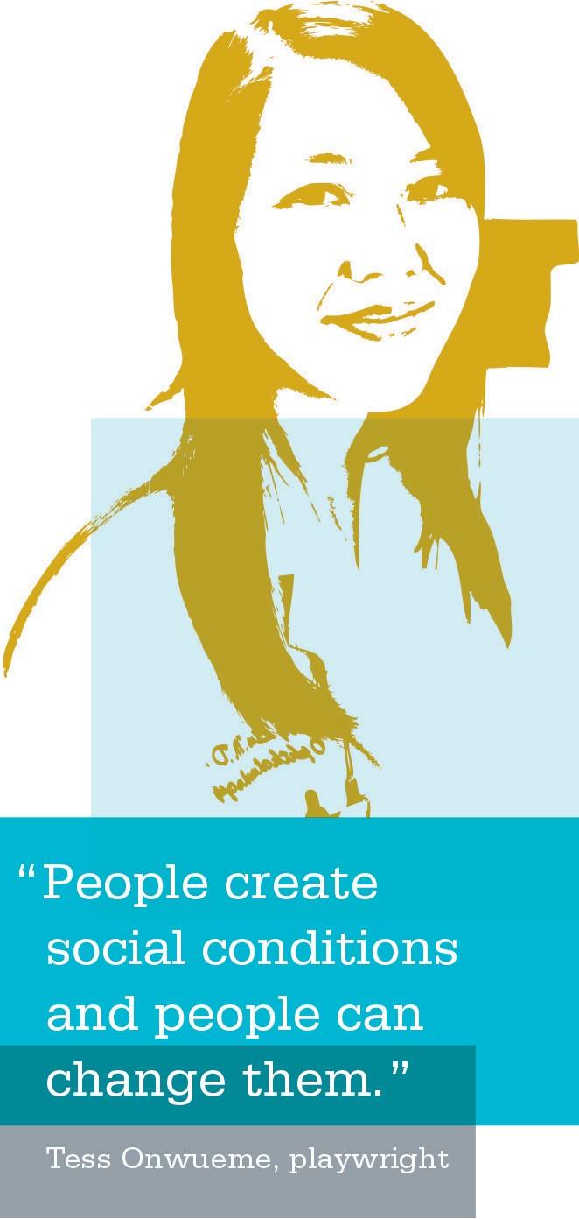
Team Vision Activity
Purpose
This activity provides team members an opportunity to look at their feelings about their own levels of commitment when preparing to establish their team’s vision. It allows the opportunity for individuals to tell a story about great and often provocative moments in a team experience. In turn,
these great moments can be translated into a foundation for the current team’s vision.

Outcomes
After successful completion of this activity, you will:
  - identify examples of components of great teams;
  - facilitate thinking and visioning of ways to recreate those great moments of the past into the present team’s experience; and
  - achieve commitment to specific initiatives and smaller, often individual, tasks for building a great team.

Instructions
Divide your team into pairs and give each person approxi- mately 10 minutes to ask all four questions of his/her partner. The person asking the questions should practice active listening and should take notes, capturing highlights of their partner’s responses.
When all the pairs are finished, ask each person to describe his/her partner’s responses, focusing on the highlights written in their notes. Record the highlights on wall charts and refer to them when developing the team’s vision, values, purpose (or mission) and goals.

ACTIVITY: Team Vision Worksheet
- Have you ever been part of a really great team? (Criteria: You felt personally committed; you signed body and soul; the team achieved extraordinary results.)

- What was different about this team? Specifically, what felt truly great about being on the “really great”team?

ACTIVITY: Team Vision Worksheet (continued)
- How can we, as a team, create those kinds of feelings here? Specifically, what could we do (achieve, accom- plish or create together) that would rekindle the same feelings we remember from the “really great” team?

- What would we commit ourselves to? (Outcome of this question: The group as a whole commits itself to one or more initiatives, often including individual commitments for part of the task. Also, a shared set of priorities may emerge.)

SECTION 2 | COMPETENCY: SUCCESSFULLY STARTING A UBT

Using the UBT Charter Activity
Purpose
The UBT charter document helps the UBT co-leads set the foundation for the work their team will do. Creating the charter agreements together will prevent confusion and disagreements from taking the team off track as team members are doing their work. It also creates a good orga- nizational structure for the team. A team charter should be used regularly to keep the team on track and within the agreed-upon scope of work. It is reviewed and revised as needed and should be shared with the sponsors.

How to Use
The team charter always is created in partnership. The charter should be created by the team during the first few meetings. For project teams, the charter typically is created by sponsors. To save time, the charter can be worked on ahead of time and presented to the team as a straw design by the co-leads.

ACTIVITY: UBT Team Charter

Purpose:

Why do we exist?

Goals and Objectives:

- What are our expected deliverables?

- How will we measure our work?

- How will we know when we’ve completed our work?

ACTIVITY: UBT Team Charter (continued)
Membership and Roles

- Composition of team?

- Co-leads?

- When and how team members are placed?

Quorum

1. How many members must be present to conduct the meeting?

 | ACTIVITY: | UBT | Team Charter (continued)
Scope |  | - How many members must be present to make consensus decisions?  - How will the team arrive at emergency decisions necessary between meetings?  - What work can be done without a quorum?  1. What are the boundaries of the team’s work?

 | ACTIVITY: | UBT | Team Charter (continued)
Decision Making |  | 2. What happens to issues not within the team’s boundaries?  - Will decisions be made by consensus?  - Will our work be in the form of recommendations or final decisions?  - What happens if we can’t reach consensus?

ACTIVITY: UBT Team Charter (continued)
Ground Rules (Working Agreements/Team Norms)

- What procedural and behavioral norms will the team agree to work within?

- Will there be norms related to potential guests, in addition to the ones used by the team?

Timelines

- How frequently will the team meet, and for how long?

- What are the important due dates connected to the project and deliverables?

ACTIVITY: UBT Team Charter (continued)
Reporting Relationships

- Who are the labor and management sponsors of this team and its work?

- Whose interests need to be represented in the work of this team?

Resources and Support

- What resources exist to help us accomplish our purpose, both internal and external?

- How do we address barriers to success?

 | ACTIVITY: | UBT | Team Charter (continued)
Communication  Confidentiality |  | 3. Whom do we go to for help?  How will information about our work be communicated to constituents, sponsors and stakeholders?  What information will be considered confidential and not communicated beyond the team’s work (KP proprietary business information, sensitive details, individual comments and conversations)?

Training Assessment Tool
Purpose
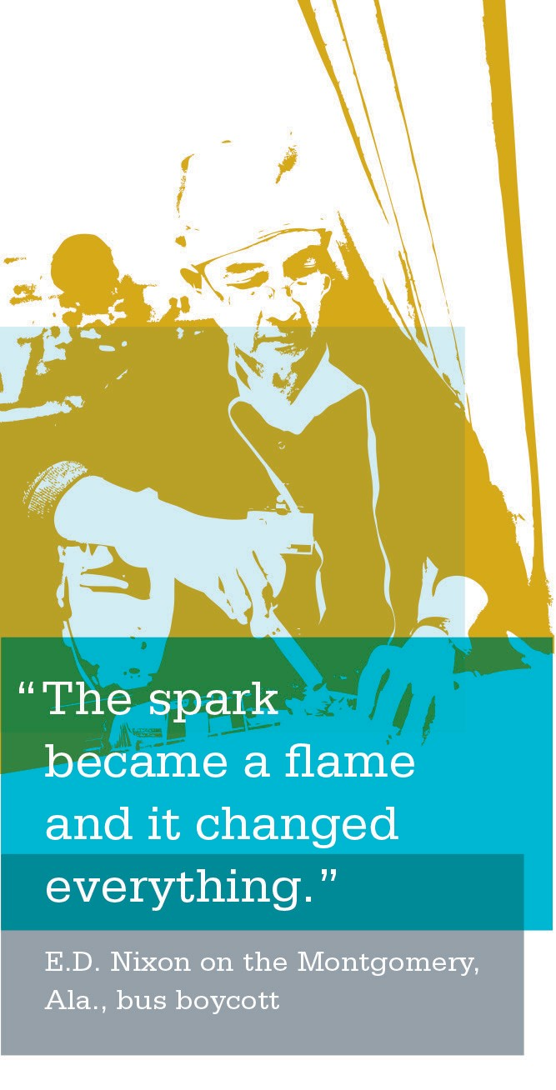
This chart can be used to identify training programs that may be useful to increase the performance of your UBT.

Outcomes
After successful completion of this tool, you will be able to identify areas in which your team may need to receive
additional training to function as a high-performing team.

Instructions
Work with your co-lead partner to complete this train- ing assessment chart after your initial kick-off meeting has taken place. You may need to revisit this tool after your team has begun the process of working together.

Training Assessment Tool Checklist
[ | ] | Check off any of the classes needed for training.
[ | ] | Identify who needs the training (this may be the entire UBT, just the co-leads or other specific parties).
[ | ] | Get in touch with your regional contact to schedule training.  (Visit www.LMPartnership.org/about/contacts/regional.html for a list of the regional contacts with phone numbers and email addresses.)
[ | ] | Identify the date of your scheduled training.

ACTIVITY: UBT Training Courses

Building a Strong Foundation for Partnership

 | Mgmt. | Union Reps. | Co-Leads | LMP  Team Members | Internal and External Consultants/ Facilitators
Unit-Based Team Orientation  (Half-Day Session) | X | X | X | X | X
Issue Resolution, Consensus Decision Making and Interest-Based Problem Solving  (Full-Day Session) | X |  | X |  | X
Corrective Action  (Full-Day Session) | X | X
Leading in Partnership Workshop  (One-Day Session) | X |  | X
Unit-Based Team Member  (Half-Day Session) |  | X |  | X
Unit-Based Team Co-Lead Workshop  (Full-Day Session) | X  (Co-lead) |  | X | X  (Co-lead)
Facilitation Skills  (Three-Day Workshop) |  |  |  |  | X

